Practical No. :- 12 Date :- 02/16/2023
Q.) Test whether the following distribution is normal or not.
173 , 206 , 179 , 257 , 198 , 251 , 239 , 246 , 295 & 261

- Solution :-
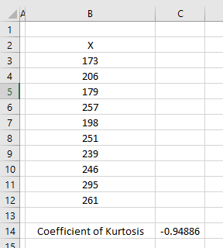

Formula used :-
- C.V of Kurtosis =KURT(B3:B12)

Conclusion :-
- The given distribution is not normal.

Practical No. :- 13 Date :- 02/16/2023
Q.) Find the Karl Person’s Coefficient of Skewness from the following record of number of Spam email per day recorded during 100 days.
No. of Spam email/day | No. of days
20 | 5
5-9 | 18
10-14 | 42
15-19 | 27
20-24 | 8
- Solution :-
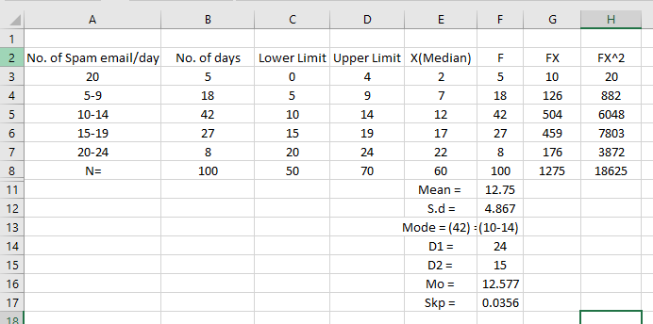
Formula used :-
- Mean (x) =G8/F8
- S.d =SQRT(H8/F8-F11*F11)
- Mode =9.5 + 24/(24+15)*5
- D1 =B5-B4
- D2 =B5-B6
- Skp =(F11-F16)/F12
Conclusion :-
- Hence , The given distribution is positively Skewed.

Practical No. :- 14 Date :- 02/16/2023
Q.) Calculation correlation Coefficient between data Size and Processed request .. Also interpret the results.
Data Size (X) | Processed Request (Y)
6 | 40
7 | 55
7 | 50
8 | 41
10 | 17
10 | 26
15 | 16

- Solution :-
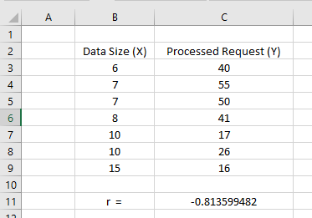

Formula Used :-
- r =CORREL(B3:B9,C3:C9)

Conclusion :-
- Hence , There is high degree negative relationship between the given Variables data Size (X) and processed request (Y).

